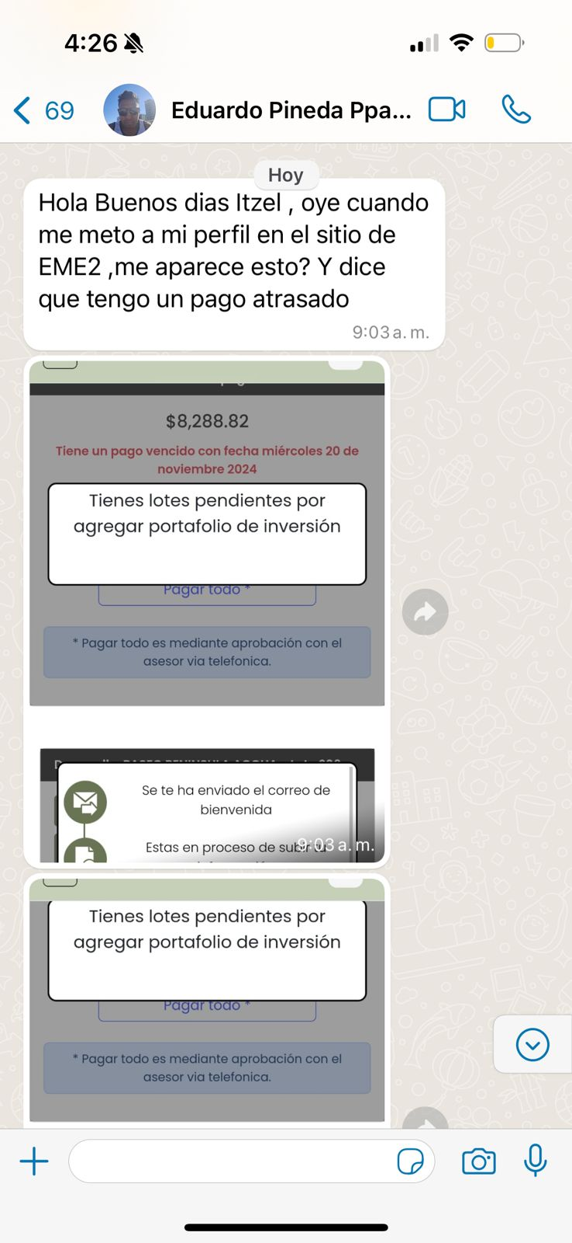

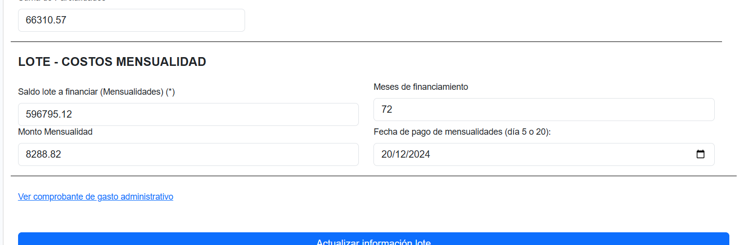

https://www.eme360.com.mx/angularcrm/crm/controlcalidad/editarhr/1121/1606/1124

